I wanna implement one of those, ready frameworks

<https://bootsnipp.com/tags/calendar>

I need sthing like that;

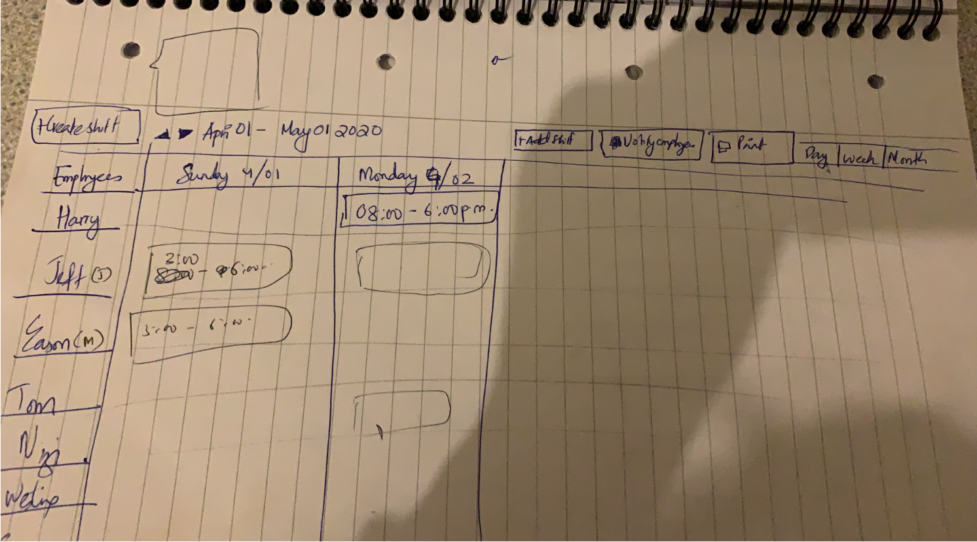

on the left, there are staff names. you click on a name, his calendar is loaded.

when I click on a blank slot, I will add a task with a simple list of fields. see below;

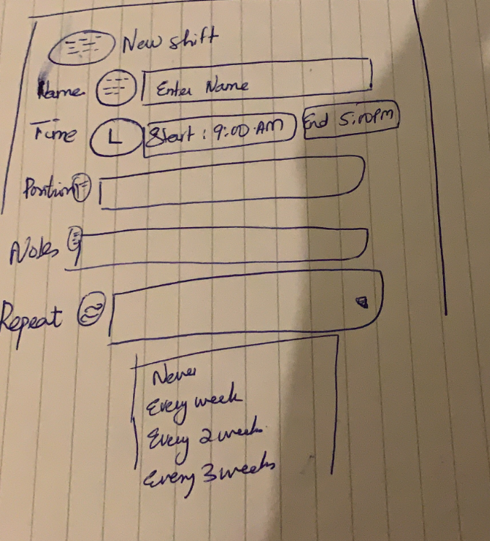

if I click on an occupied slot; I will see details in it, and will be able to update fields and close

I also want to drag and drop tasks from one slot to another.

Just Front-End needed : Daily, Weekly, Monthly views ; previous/next buttons, etc.

Seems like this one is fitting best, but I am open to proposals : <https://bootsnipp.com/snippets/PEZZ7>